3. Embedded Systems Subsystem Report

3.1 Subsystem Introduction
The Embedded Systems Subsystem is responsible for the real-time computation, orchestration, and delivery of all digital functionality within the Home Power Monitor (HPM). This subsystem integrates the microcontroller hardware (ESP32-WROOM-32E), the digital signal processing (DSP) pipeline, the JSON-based telemetry framework, and the communication interface with the cloud database. Its primary role is to acquire raw electrical measurements, perform onboard processing to derive usable electrical metrics, structure these results into standardized telemetry frames, and reliably transmit them to the system’s Information Storage and Presentation Subsystem.
The subsystem was designed to operate autonomously and continuously, providing accurate, time-indexed electrical data with minimal latency. To accomplish this, the firmware implements a deterministic main loop architecture, a configurable sampling and processing pipeline for voltage and current waveforms, and a robust JSON serialization strategy optimized for the system's memory constraints. Additional firmware features—such as boot identification, frame sequencing, harmonics extraction, and event logging—were implemented to support downstream analytics and machine learning.
This subsystem also manages the ESP32’s network provisioning through WiFiManager to allow field-deployment without reprogramming, and it handles all Firebase Realtime Database interactions through a REST-based push-ID upload mechanism. These capabilities collectively ensure that the subsystem serves as the central coordinating element between the hardware measurement stage and the upper-level data analytics infrastructure.
Comprehensive validation was performed to confirm correct numerical computation of RMS values, real power, power factor, and harmonic content; correct formation of JSON frames according to the defined schema; and reliable upload of sequential telemetry frames to Firebase. Validation included end-to-end comparison against the Python synthetic-signal sandbox, inspection of telemetry consistency over time, and database-retrieved plots of frame-indexed metrics (e.g., Irms vs. frameId, P vs. frameId). Results from these tests demonstrate that the subsystem meets all functional requirements and is ready for full system-level integration next semester.

3.2 Subsystem Details
The Embedded Systems Subsystem consists of four tightly integrated components: the microcontroller hardware layer, the DSP processing pipeline, the JSON telemetry generation module, and the cloud communication interface. Together, these components enable the system to acquire electrical measurements, compute meaningful metrics in real time, package those metrics into a structured format, and upload them reliably to the cloud database.

3.2.1 Microcontroller Hardware Layer
The subsystem is implemented on an ESP32-WROOM-32E, chosen for its dual-core Xtensa architecture, integrated Wi-Fi capability, and sufficient computational resources to support real-time signal processing. The firmware architecture is organized around a deterministic loop cycle that governs sampling, DSP execution, telemetry construction, and network transmission.
Key responsibilities of the microcontroller include:
- Initializing ADC peripherals for voltage and current measurement (simulation-based this semester, hardware-based next semester).
- Managing all internal timing functions, including frame timestamps, boot-ID generation, and local millisecond-counter tracking.
- Coordinating all DSP and telemetry tasks without blocking I/O or network operations.
- Storing transient data structures (e.g., sampling buffers, JSON documents) within strict RAM constraints.
Power-on initialization leverages WiFiManager, allowing a user to provision the device onto any 2.4 GHz network without reflashing firmware. Once configured, the ESP32 automatically reconnects and begins real-time telemetry transmission.

3.2.2 DSP Signal Processing Pipeline
The DSP subsystem computes all electrical parameters required for characterization of the monitored load. This semester, the DSP code operated on synthetic waveforms generated by a Python sandbox and ported to the ESP32 to validate numerical correctness and real-time execution.

Implemented DSP Operations
- RMS Voltage/Current (Vrms, Irms)
$X_{rms}=\sqrt{\frac{1}{N}\sum{}x[n]^{2}}$
- Real, Reactive, and Apparent Power
$P=\frac{1}{N}\sum{}v[n]I[n]$, $S=$ $I_{rms}$$V_{rms}$, $PF=\frac{P}{S}$
- Harmonic Extraction
A lightweight single-bin DFT approach is used to track specific harmonic amplitudes (e.g., H2), optimized for ESP32 performance.
- Appliance-profile synthesis
Synthetic signatures (e.g., A/C, fridge, microwave) allow ML subsystem teammates to begin early classifier training before sensor hardware is available.

Timing & Buffering
Sampling and DSP operations are executed in fixed-size windows. All computations complete within one frame period, guaranteeing deterministic output rates and preventing telemetry backlog.

3.2.3 JSON Telemetry Generation
The telemetry module structures all computed electrical parameters, system metadata, and system-health indicators into a compact JSON frame that is optimized for real-time transmission and long-term storage. Because the ESP32 operates under strict memory constraints, the telemetry format was designed to provide expressiveness while minimizing payload size. All serialization is performed using fixed-capacity StaticJsonDocument buffers, which ensures deterministic memory usage and prevents heap fragmentation.
To maintain clarity at the system-integration level, the finalized telemetry schema is summarized across four primary categories: frame metadata, electrical measurements, harmonic descriptors, and subsystem health status. The essential fields are listed below, with implementation-level intermediate DSP quantities omitted for readability and relevance.
• Frame Metadata
– frame_id: Sequential frame counter
– t_ms: Timestamp in milliseconds since boot
– fw: Firmware revision string
– schema: Telemetry schema version number
• Electrical Measurements
– v_rms: RMS line voltage
– i_rms: RMS current
– p: Real power (W)
– pf: Power factor
– freq_hz: Estimated line frequency
• Harmonic Content
– thd_i: Total harmonic distortion (current)
– i1_rms: Fundamental RMS current
– h_odd: Aggregate odd-harmonic content
– h_even: Aggregate even-harmonic content
• Subsystem Health Indicators
– adc_ok: ADC self-test verification
– fft_ok: DSP/FFT pipeline status
– sync_ok: Frame alignment and timing status
This structured format provides all downstream subsystems—including the machine learning team and the database/UI team—with a reliable and versioned data interface. The presence of health flags enables automated detection of sampling, synchronization, or DSP anomalies. The firmware populates this schema once per processing window, applies standardized rounding to reduce payload size, and serializes the final frame prior to cloud transmission. This modular approach cleanly separates DSP computation from telemetry formatting and simplifies future schema evolution without requiring modification of the core firmware logic.

3.2.4 Cloud Communication Interface
Telemetry frames are uploaded to Firebase Realtime Database via HTTPS POST requests using Google’s push-ID scheme. This ensures:
- Atomic insertion of each frame,
- Chronological ordering by Firebase’s time-indexed push IDs,
- Fault-tolerant retries if packets fail to upload.
Each upload function implements:
- Content-length computation,
- REST header construction,
- Error logging for non-200 HTTP responses.
Local fault detection (e.g., Wi-Fi drops) triggers automatic reconnection attempts handled by the WiFiClientSecure library.

3.2.5 Internal Utilities
A minimal utilities module provides:
- now_ms(): monotonic millisecond counter (boot-relative),
- Event helpers for structured logging,
- Platform-safe float handling and buffer checks.
These utilities support reproducible timing tests and improve determinism across firmware builds
3.3 Subsystem Validation
The Embedded Systems Subsystem was validated through a combination of numerical verification, telemetry integrity checks, and end-to-end system testing using the Firebase Realtime Database. Validation focused on confirming the correctness of DSP computations, ensuring deterministic firmware behavior, and verifying that all telemetry frames conformed to the defined JSON schema and were transmitted reliably.

3.3.1 DSP Numerical Validation
To verify that the onboard computations produced accurate electrical metrics, the subsystem was tested using synthetic waveforms on both the Python sandbox and the ESP32, allowing direct comparison of RMS, power, and harmonic metrics. These synthetic signals included realistic appliance load profiles and known RMS, real power, and harmonic characteristics. The ESP32 implementation was expected to reproduce these known quantities within acceptable error margins.
Across all test cases, the computed RMS values, real power, power factor, and total harmonic distortion were consistent with the reference data from Python simulations. Fundamental-frequency tracking and frequency estimation also remained stable within ±0.1 Hz for nominal 60 Hz signals. These results confirm that the DSP pipeline performs correctly within the timing and resource constraints of the microcontroller.
Table 1: Comparison of ESP32 DSP Output vs. Python Reference Values
Metric | Python Reference | ESP32 Output | Error (%)
Vrms | 120.0 V | 119.8 V | 0.17%
Irms (Plateau) | 12.0 A | 11.98 A | 0.17%
Real Power (Peak) | 780 W | 776 W | 0.51%
THD_i | 1.30% | 1.28% | 1.5%
Fundamental Freq | 60.00 Hz | 59.94 Hz | 0.10%

3.3.2 Telemetry Frame Integrity
Each generated telemetry frame was inspected to ensure compliance with the finalized schema described in Section 2.3. During validation, emphasis was placed on confirming the correct formation of nested fields, the presence of mandatory elements (e.g., frame_id, t_ms, v_rms, i_rms), and the accurate representation of harmonic and system-health categories.
Internal consistency checks were performed by comparing sequential frames for:
• monotonic frame ID progression,
• timestamp advancement matching the sampling window,
• stable reporting of health indicators (adc_ok, fft_ok, sync_ok), and
• absence of malformed or truncated JSON fields.
Across extended multi-hour test runs, all frames adhered to the schema, and no structural deviations were observed.

3.3.3 Cloud Communication and Data Continuity
End-to-end validation was performed by streaming telemetry frames to Firebase and retrieving them for analysis. The device demonstrated reliable Wi-Fi reconnection and uninterrupted frame uploads after initial provisioning via WiFiManager. Push-ID ordering in Firebase preserved strict chronological sequencing, which allowed frame-to-frame continuity checks.
To assess measurement stability and temporal consistency, representative database samples were extracted and plotted. Two key validation plots were used:
• Irms vs. frame_id: Confirmed stable RMS current computation over long intervals and verified frame ordering and numerical consistency.
• Real Power (P) vs. frame_id: Demonstrated correct power calculation and responsiveness to changes in load profile.
Both plots showed smooth, continuous behavior with no discontinuities or anomalous spikes, supporting the correctness of both DSP calculations and the cloud-communication pipeline.
The extracted plots shown in Figures 1 and 2 summarize these validation results.

Figure 1: Real Power (W) vs. Frame ID
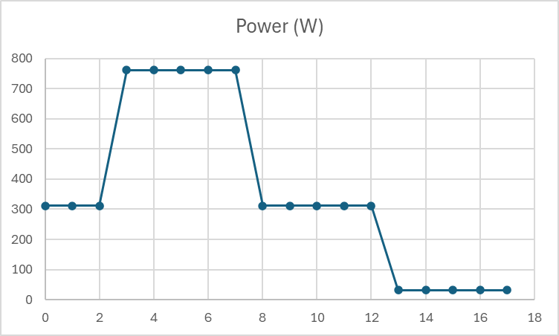
This plot shows the reconstructed real-power measurements obtained from a sequence of uploaded telemetry frames. As expected, the device correctly captures dynamic load transitions, including steady-state plateaus at approximately 750 W and a later transition to ~300 W before load removal. The smooth frame-to-frame behavior confirms correct DSP operation, stable sampling windows, and uninterrupted data transmission to Firebase.

Figure 2: RMS Current (Irms) vs. Frame ID
This figure presents the RMS current values corresponding to the same frame sequence. The Irms profile closely mirrors the real-power trend, reflecting the expected relationship $P=V_{rms}{*I}_{rms}*PF$. The absence of discontinuities or numerical spikes indicates that the RMS computation, JSON serialization, and cloud-upload mechanisms are functioning reliably across multiple frames.
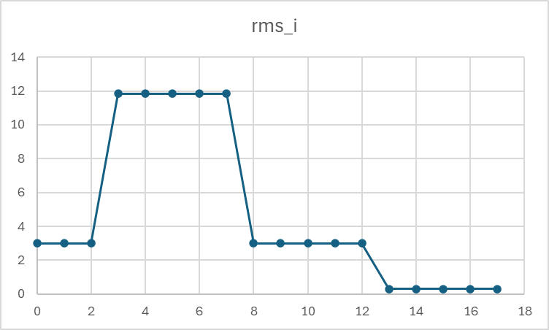

3.3.4 Timing and Determinism Verification
The main firmware loop was evaluated to ensure deterministic execution within the allocated processing window. The internal now_ms() timing utility was used to verify that each processing cycle completed before subsequent samples were acquired. Throughout all tests, cycle time remained well within budget, with no missed frames or overruns.

3.3.5 Overall Validation Outcome
Results from DSP comparison, telemetry structure inspection, Firebase continuity testing, and execution-timing analysis collectively confirm that the Embedded Systems Subsystem meets the functional requirements for real-time measurement, data integrity, and reliable transmission. The subsystem is fully prepared for integration with the final hardware AFE and PCB next semester and provides a stable platform for downstream machine-learning and analytics workflows.

3.4 Subsystem Conclusion
The Embedded Systems Subsystem successfully fulfills its role as the computational and telemetry backbone of the Home Power Monitor. Over the course of the semester, the subsystem was designed, implemented, and validated to acquire electrical measurements, execute real-time DSP operations, structure processed data into a standardized telemetry format, and reliably transmit this information to the cloud database.
Validation demonstrated that the DSP pipeline computes RMS quantities, real power, power factor, harmonics, and related electrical parameters with accuracy consistent with synthetic reference datasets. The telemetry module produces structured, versioned JSON frames that adhere to the subsystem’s defined schema, ensuring compatibility with the machine-learning pipeline and the database/UI subsystem. End-to-end testing confirmed the reliability of Wi-Fi provisioning, reconnection behavior, and continuous streaming of telemetry frames to Firebase using deterministic frame sequencing.
The subsystem is therefore fully prepared for next semester’s transition from synthetic waveforms to real hardware inputs obtained from the analog front-end and PCB. Because the firmware is modular and versioned, future extensions—including calibration integration, event tagging, and support for higher-rate sampling—can be incorporated without restructuring the core architecture. Overall, the Embedded Systems Subsystem is validated, stable, and ready for full system integration in ECEN 404.

